|  |  |
| --- | --- |
| E-Scooter project  Current Name: EGO-SCOOTER | TEam members:  LIU Huayu  ZHU ying  MAO Yuqing  Adil akarkach |

Table of contents

Business Description: 2

UI PROTOTYPE: 2

Planning: 4

Sprint Reviews: 6

USE CASES: 7

DIAGRAMS: 26

Class Diagram: 26

Sequence Diagrams: 27

Activity Diagram: 30

Use Case Diagrams: 31

# Business Description:

Our development team seeks to create an easy solution for inner-city transportation that is both quick, easy and safe. Our current project name will be “EGO-SCOOTER”. Inner city transportation is rarely thought about, despite the rapid change and technological progress in every other area of life. We want to keep up this trend and finally bring an end to primitive walking, with this brand-new technological advancement. The scooters will be distributed throughout the city and soon change it’s landscape. The rechargeable and environmentally friendly lithium-ion batteries in the scooters can cover a range of 25km while operating at a maximum speed of 20km/h. We hope to revolutionize personal transportation and help reduce car traffic, reduce traffic accidents, reduce time spent traversing the mortal planes- and most importantly bring a new fresh and fun way to explore YOUR city

## UI PROTOTYPE:

Start Screen Main Screen

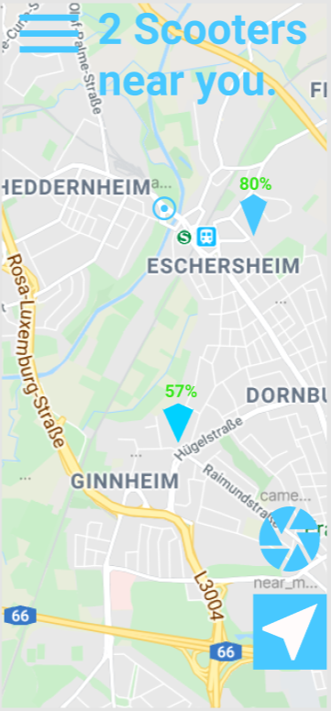

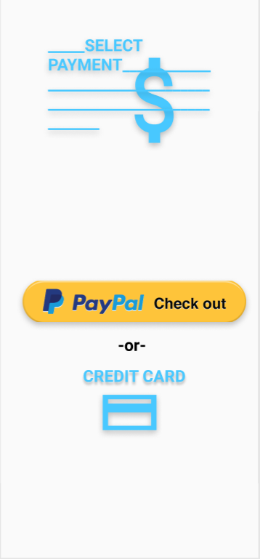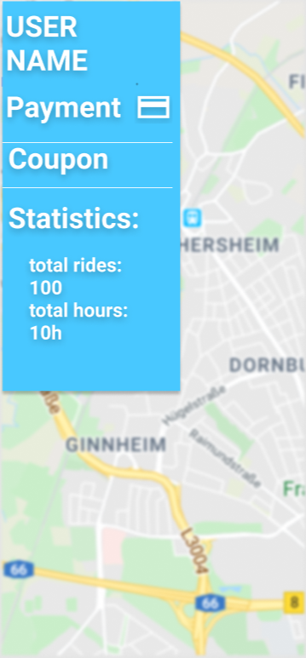Drop Down menu opened Payment Option Screen

# Planning:

## 

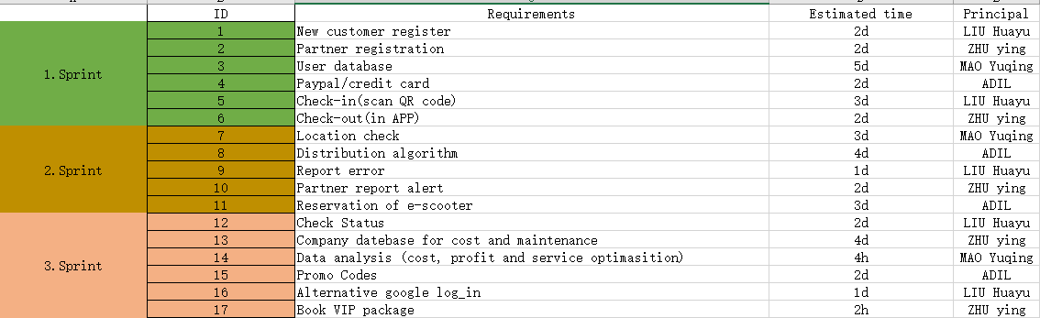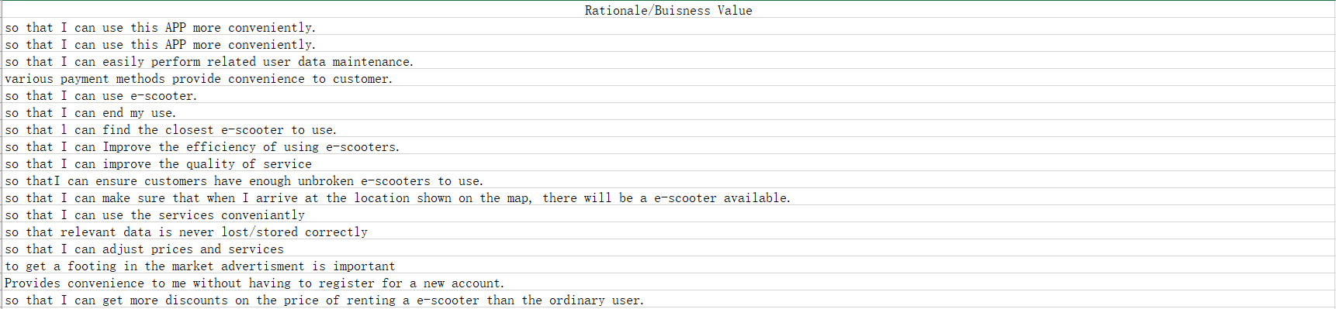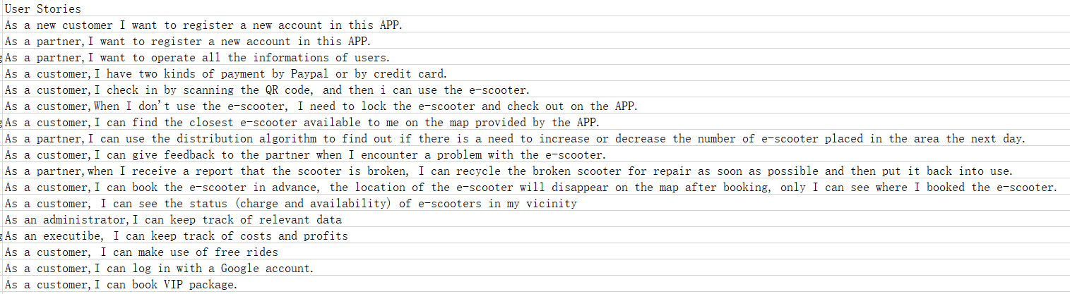

# Sprint Reviews:

**Sprint 1 (20.12.19-03.01.20):**

Registration:

Planning the registration processes proved to be more difficult than estimated.

Some discussion arose about how to distinguish a regular user from a partner. We decided on a separate registration process for partners. The main idea being that partners can see exclusive information (error reports for example) about e-scooters and also need no extra payment for rides, so that they can do their work recharging and maintaining the e-scooters more easily.

Databases:

We unanimously decided to limit its content to the basic registration data, user ID and location. The main concern was for this sprint to ensure a working database architecture that can be maintained and adjusted for later developments easily. This basic database should be more than sufficient for the beta release of the application.

Payment and use:

We discussed payment option and later opted to also include credit card payment. In some countries paypal is not common (China for example). E-scooters should be accessible to all tourists and locals, we decided.

Scanning a QR code: Each e-scooter has its unique ID that has to be attributed to each unique e-scooter. The scooter, we thought, could be identified by a QR sticker. The advantage is that the scooters ID can always be scanned no matter if the e-scooter is charged or not. So we decided as a team to use a QR code system.

Checking out should be equally simple by just pressing an in-app button, that locks the scooter up. It is very important to keep this step as simple as possible (for the user).

Sprint retrospect (by Liu Huayu):

We were very pleased with our progress. The estimated time was chosen generously and despite some delays we finished everything in the planned time frame. In the sprint we mainly used brainstorming as our means of gathering ideas. There was a language barrier that could be bridged by cooperation and clever use of a translation service. Overall communication could be further improved by applying more clear and concise leadership by the scrum master. Some delays could have been prevented if the tasks would have been made more clearly. The creation of the diagrams also messed with our estimate as some functionalities had to be first correctly understood to be applied. In the upcoming sprints creation of the diagrams would be far quicker, probably even exceeding our estimates. Brainstorming proved to be effective and will be applied to the next sprints as well.

**Sprint 2 (02.01.20-14.01.20):**

GPS:

For the map we looked for a free GPS service and finally decided to use [www.gps-server.net](http://www.gps-server.net). It was very important to us to have reliable GPS as this was the backbone of the entire project. [www.gps-server.net](http://www.gps-server.net) provides us with all functionalities that we looked for and also the most important feature: it could be modified and fed with our data.

Distribution Algorithm:

It is obviously of this algorithm and cross communication with the GPS provider was difficult to realize. Finding a metric on which this algorithm should chose the final locations lead to many heated discussions in the development team.

Report System:

We decided on a standard report ticket system. Inspiration for this could be found everywhere and we decided not to reinvent the wheel and just stick to this very basic idea.

Reports are sent out to all partners by a notification dispatcher, again a very basic idea that we quickly came to consensus about.

E-Scooter reservation:

We were not sure in the beginning weather this functionality was needed. But we opted for it as we imagined a scenario in which a user walks towards an e-scooter just to have it taken away in the last second. The map also has to update accordingly, greying out reserved e-scooters. Problems that could arise: users could reserve multiple e-scooters to damage the service. Despite that we decided in favor of this function as we deemed it a very low risk. Each user could only reserve 1 e-scooter at a time and also only for a fixed time frame. The first version of the application should be released with this function. Patches could be implemented if unforeseen events occur.

Sprint retrospective (by Adil Akarkach):

We started our second sprint with a lot more efficiency. Creating diagrams became routine work. Communication was also improved by using a famous chat service to send around files that could be edited by multiple people at once. These files made it easier to compile the progress and work-flow of other team members. A substantial improvement to the first sprint. Brainstorming now often consisted of splitting the work up between team members and having it reviewed by the rest of the team (more checks and balances). Those files could be edited by every other team member. They were usually loose excel files that would not find their way into the final documentation- they could much rather be seen as the byproduct of a brainstorming session. This is to be implemented in the next sprint session as well. This sprint was not without its difficulties. Sometimes misunderstandings happened (naming conventions were not properly enforced for example). This time a lot more clearly direction and planning went into the working progress, yet for the next sprint longer meetings and more peer reviewed work has to be implemented, to ensure integrity.

**Sprint 3(14.01.20-31.01.20):**

Map design:

The map has to keep the user updated. We decided to color code the availability of e-scooters on the map (green available/grey in use).

Data Analysis:

We deemed setting up a database as a main collection of all relevant business information necessary. What constitutes relevant information had to be discussed which lead to delays. The database should finally collect payment data, maintenance costs and use frequency.

Data analysis is always one of the most difficult parts. We thought about outsourcing this to a contractor. The application would be operational for testing with or without data analysis. But for a company to return the highest possible profits this is still very important.

Coupons and bonuses:

To get a footing in the market we decided to occasionally reward coupon codes for free rides

This kind of partnership was swiftly agreed upon because- as our research showed, this was a significant incentive for customers to us one app over another without this option.

VIP accounts: A new model that would revolutionize inner city transportation. With a VIP-account (monthly fee) the user could access all e-scooters without worry, as long as subscription lasts. This was controversial. In the first version of this application this should definitely be implemented. This is a low priority item and more of a testing ground idea. Might be rolled out in the final version

Sprint retrospective (by Mao Yuqing):

The time constraint was pressing. We did not take editing of the documents and error correction into account. Over-all creation of the relevant diagrams and use cases proved to be routine work at this point- at least when it came to the technical skills with the software. The actual contents especially when it came to small inconsistencies proved time consuming to fix. We used word to compile our results into one final document. A mistake as word is notoriously inconsistent (incredibly unstable formatting). Small changes that accumulated over the course of the last sprints took hours to fix. A remedy for this would be to use a) a better text editor and b) to plan out the format of the document before adding in the details.

<<<ADD 8 HERE>>>>

# USE CASES:

|  |  |
| --- | --- |
| ID | 1 |
| Use Case Name | New Customer Registration |
| Primary Actor | Customer |
| Further Actors | Admin |
| Stakeholder Interest | Customer: needs to create an account to get past the log-in screen and use the services  Admin: needs a database of customers, to provide services for |
| Trigger | Filling in the needed information and pressing “register”. |
| Pre-Conditions | communication with the server is possible and the checks for errors in registration are set in place. |
| Post-Conditions | Access to the main functionalities of the app are granted |
| Basic Course (Succes Scenario) | The customer creates a valid account. |
| Alternative Course | registration process is repeated:  Case1: The customer entered a weak password  Case2: the customer entered an already used e-mail address. |

|  |  |
| --- | --- |
| ID | 2 |
| Use Case Name | Partner Registration |
| Primary Actor | Partner |
| Further Actors | Admin |
| Stakeholder Interest | Partners: need special access with information granted only to them to do maintenance and distribution of the scooters  Admin: Preventing fraudulent registrations |
| Trigger | Partners have used the partner registration tab in the app |
| Pre-Conditions | The entire project needs to be operational. |
| Post-Conditions | none |
| Basic Course (Succes Scenario) | Partners have an account that distinguishes them from ordinary users. |
| Alternative Course | registration process is repeated:  Case1: The partner entered a weak password  Case2: the partner entered an already used e-mail address. |

|  |  |
| --- | --- |
| ID | 4 |
| Use Case Name | Payment Method/PayPal |
| Primary Actor | Customer |
| Further Actors | PayPal |
| Stakeholder Interest | PayPal: by being used as the primary payment method in many applications, PayPal gains influence and grows.  Customer: is provided with an easy and quick payment method. |
| Trigger | User selected an e-scooter |
| Pre-Conditions | The e-scooter GPS map was accessed by a logged-in user, who furthermore decided on a particular scooter by scanning its QR code. |
| Post-Conditions | The e-scooter is now unlocked and operational. It has to also track the distance and be lockable again. |
| Basic Course (Succes Scenario) | The user safes the PayPal information in his/her customer account and can pay with just one convenient click |
| Alternative Course | The user does not have PayPal.  No other payment method is offered except for the occasional vouchers. |

|  |  |
| --- | --- |
| ID | 4 |
| Use Case Name | Credit Card Payment |
| Primary Actor | Customer |
| Further Actors | none |
| Stakeholder Interest | Customer can pay with credit card |
| Trigger | Selecting the payment method |
| Pre-Conditions | Server communication |
| Post-Conditions | Credit card account properly billed |
| Basic Course (Succes Scenario) | In the best case the payment will be just as quick as PayPal and the customer can unlock the e-scooter |
| Alternative Course | Case1: Credit Card balance is exceeded: scooter stays locked and warning message is sent  Case2: Credit Card information is false: Scooter stays locked and user account gets suspended |

|  |  |
| --- | --- |
| ID | 5 |
| Use Case Name | User Check-In/QR Scan |
| Primary Actor | Customer  Partner |
| Further Actors | none |
| Stakeholder Interest | Customer: can access a unique e-scooter and pay for its use  Partner: can scan in the QR codes for free rides |
| Trigger | User is asked to scan in QR code (instructions on a plate on the e-scooter) and clicks on the “scan” button |
| Pre-Conditions | Customer gave permission to the app to use the camera. |
| Post-Conditions | Payment with PayPal is presented as an option and the e-scooter is correctly identified for use. |
| Basic Course (Succes Scenario) | User can intuitively select an e-scooter after being guided to it by the GPS maps routing option. |
| Alternative Course | Unsuccessfully scanning the code.  Case 1: a malicious agent vandalized the QR plate. In this case a partner reports this to the admin.  Case 2: it is too dark. User is prompted to use the flashlight after 3 unsuccessful attempts |

|  |  |
| --- | --- |
| ID | 6 |
| Use Case Name | Customer Check-out |
| Primary Actor | Customer |
| Further Actors | Partners |
| Stakeholder Interest | Customer: after a ride the customer can place the e-scooter anywhere in the city for convenience  Partners & Customers: profit from keeping track of the new e-scooters locations via GPS map. |
| Trigger | The customer finishes his/her ride and pushes the “stop-ride” button on the scooter |
| Pre-Conditions | The user must have had unlocked an e-scooter |
| Post-Conditions | The e-scooter is now on a new location and the GPS map is updated. The e-scooter is also set to “locked” and can now be seen on the GPS map. |
| Basic Course (Succes Scenario) | The customer has a good ride and does not need to worry about returning the e-scooter to a specific location. The GPS map is updated accordingly and partners restore a better distribution of the e-scooters after every recharging. |
| Alternative Course | Case1: the customer forgets to lock the e-scooter. In the worst case another agent may continue to ride it and the customer gets billed unfairly. A safety measure is that every idle e-scooter is set to locked automatically after 5 minutes of no use. |

|  |  |
| --- | --- |
| ID | 7 |
| Use Case Name | Location check |
| Primary Actor | Customer |
| Further Actors | none |
| Stakeholder Interest | Customers need to see the closest locked and loaded e-scooter in their proximity |
| Trigger | The user activates GPS on their device and taps on the e-scooter icon |
| Pre-Conditions | GPS from the provider “gps-server.net“ is properly configured and the customer is logged in |
| Post-Conditions | The user sees a shortest route to the next available scooter |
| Basic Course (Succes Scenario) | The user is directed to the next e-scooter. |
| Alternative Course | The e-scooter is snatched by another customer. The map gets updated and the user can select the next closest -scooter. |

|  |  |
| --- | --- |
| ID | 9 |
| Use Case Name | Report error |
| Primary Actor | Partner |
| Further Actors | User, System |
| Stakeholder Interest | Partner: can report errors directly to the admin  User: no duty to report errors but has in theory the same possibility to do so  System: receives all the error reports and saves them |
| Trigger | User or partner leave a report comment |
| Pre-Conditions | Scanned in the QR code of an e-scooter and found it non-functional |
| Post-Conditions | E-scooter will be retrieved and checked by partner and either replaced or fixed |
| Basic Course (Succes Scenario) | Error is reported and saved to the system. The broken e-scooters will then exchanged for new ones |
| Alternative Course | none |

|  |  |
| --- | --- |
| ID | 10 |
| Use Case Name | Partner report alert |
| Primary Actor | Partner |
| Further Actors | System |
| Stakeholder Interest | Partner: receives information where a failed e-scooter is located |
| Trigger | System distributes reported e-scooter information to all partners automatically |
| Pre-Conditions | Systems database must contain the information |
| Post-Conditions | Delete item from database after the problem is fixed |
| Basic Course (Succes Scenario) | The message of a reported e-scooter reaches all partners to ensure functionality for all customers |
| Alternative Course | none |

|  |  |
| --- | --- |
| ID | 11 |
| Use Case Name | Reservation of e-scooter |
| Primary Actor | Customer |
| Further Actors | none |
| Stakeholder Interest | Customer: can reserve an e-scooter and make it impossible for another person to unlock it. The e-scooter can not be snatched away |
| Trigger | Customer taps on e-scooter icon displayed on the map |
| Pre-Conditions | Map is showing proper locations of active e-scooters |
| Post-Conditions | E-scooter the customer reserved is greyed out for all other users |
| Basic Course (Succes Scenario) | The customer can select any e-scooter in his/her proximity and reserve it for themselves |
| Alternative Course | none |

|  |  |
| --- | --- |
| ID | 15 |
| Use Case Name | Promo Code |
| Primary Actor | Customer |
| Further Actors | Company |
| Stakeholder Interest | Company: for promotion purposes, coupons are granted for special events.  Customer: enjoys a free ride |
| Trigger | Customer types promo code into the promo bar |
| Pre-Conditions | Promo Codes must have been validated by the company’s marketing department and created by the Company’s IT department |
| Post-Conditions | Promo code is now disabled in customers account (a code can only be used once) |
| Basic Course (Succes Scenario) | Promo is typed in and the customer is rewarded a free ride. The system can not be abused |
| Alternative Course | Case1: Promo invalid, no free ride granted  Case2: Promo is expired or has already been used, no free ride granted  Case3: fraud, user account is suspended |

|  |  |
| --- | --- |
| ID | 16 |
| Use Case Name | Alternstive google log_in |
| Primary Actor | Customer |
| Further Actors | none |
| Stakeholder Interest | Customer: another way to log in app |
| Trigger | Customer uses app as a new user, he could have another way to register and log in directly |
| Pre-Conditions | Customer is given permssion by Party 3 platform(eg:google) |
| Post-Conditions | Customer can use app successfully |
| Basic Course (Succes Scenario) | User can log in app, and also there is not a unique way to login. |
| Alternative Course | Unsuccessfully login.  Case 1:The network is bad ,so that it couldn’t log in.  Case 2:Response time too long ,restart log in. |

|  |  |
| --- | --- |
| ID | 17 |
| Use Case Name | Book VIP package |
| Primary Actor | Customer |
| Further Actors | Company |
| Stakeholder Interest | Customer:  Have discount riding the E-scooter  Company  Attract more customer. |
| Trigger | Customer orders the VIP package in app. |
| Pre-Conditions | Customer log in successfully,and hava effective payment. |
| Post-Conditions | Customer becomes VIP and could use VIP package |
| Basic Course (Succes Scenario) | Customer gets a VIP package and can ride E-scooter cheaper. |
| Alternative Course | Failed use VIP package.  There is a deadline,need a voucher. |

# DIAGRAMS:

## Class Diagram:

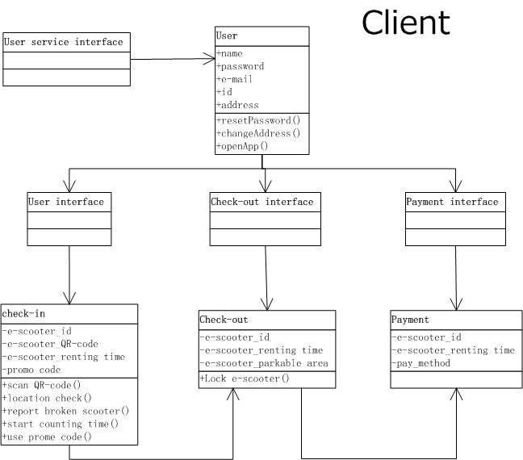

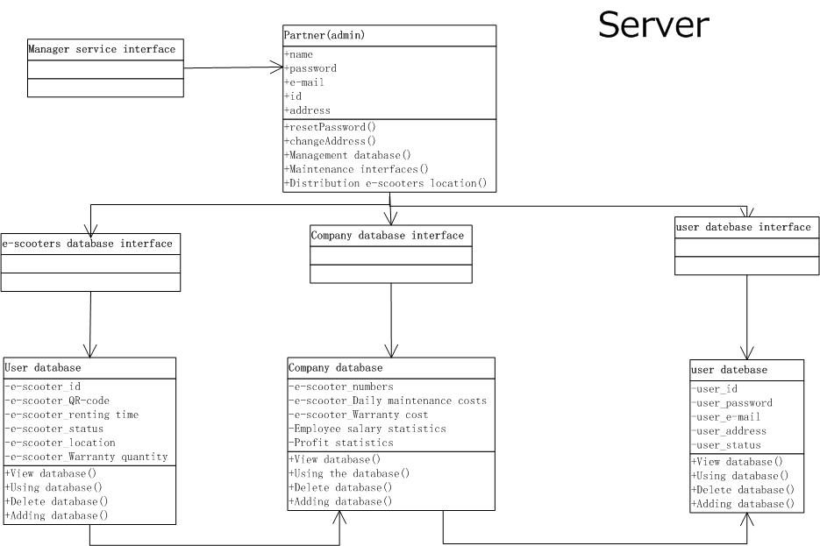

## Sequence Diagrams:

New customer register: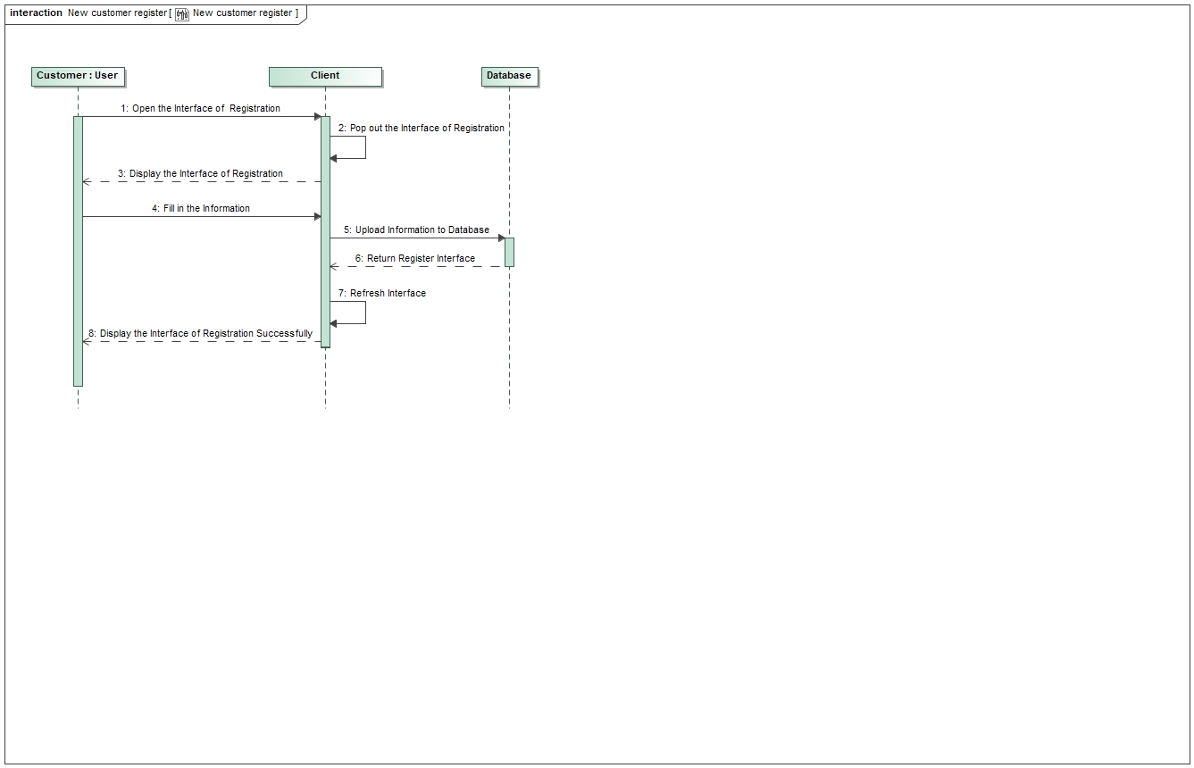

Partner registration: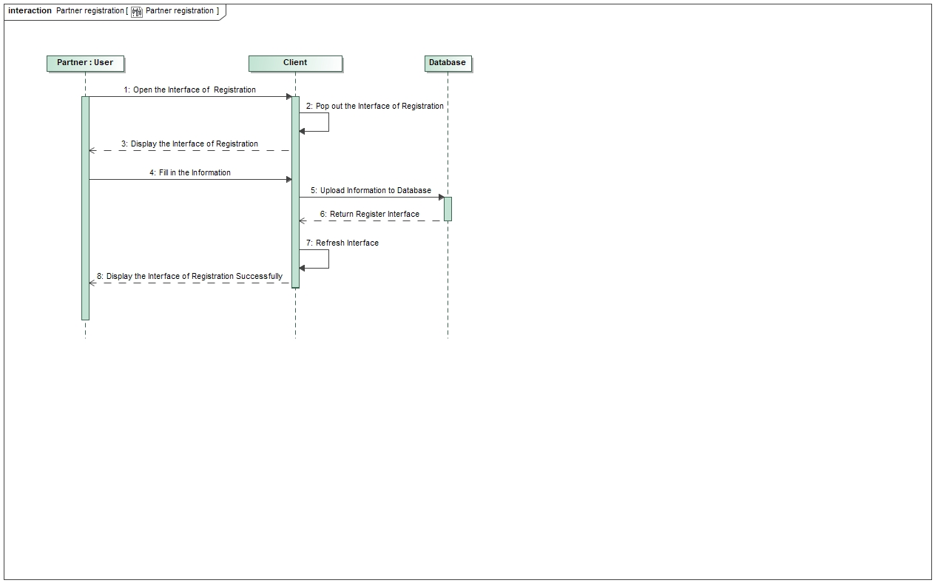

PayPal/credit card:

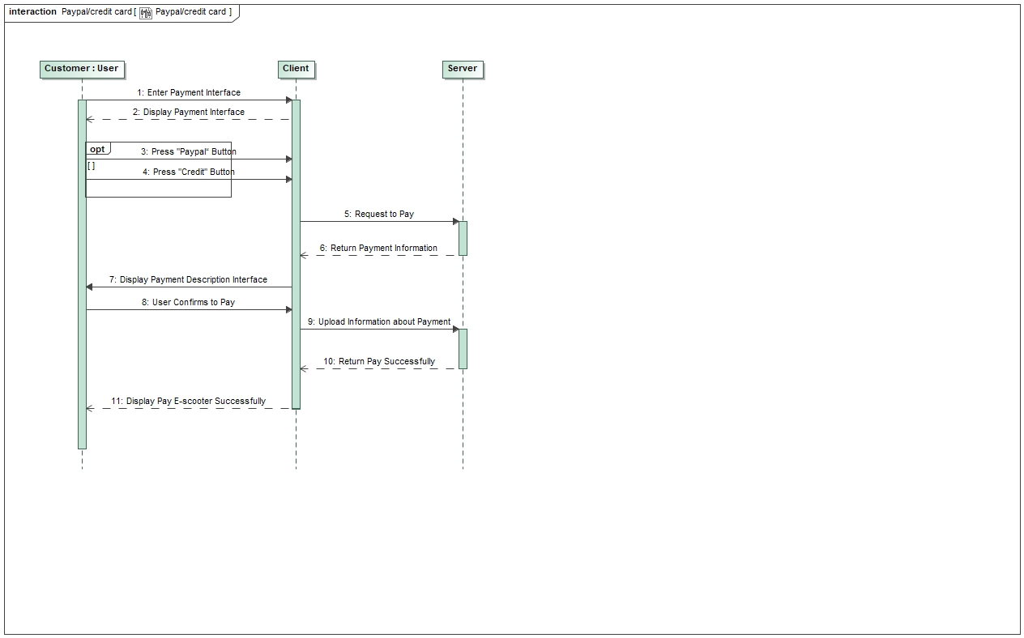

Check-in(scan QR code):

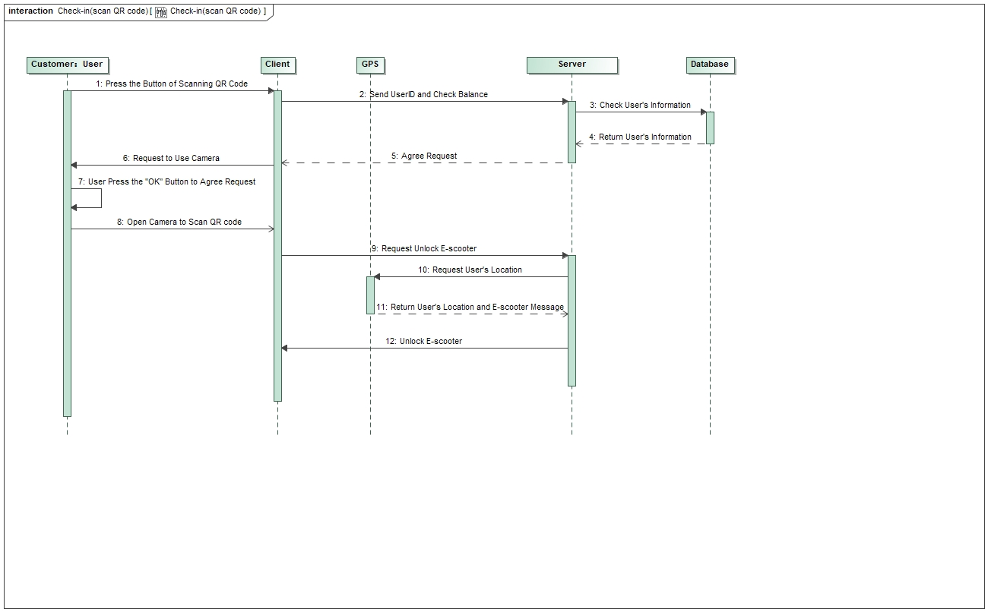

Check-out(in APP):

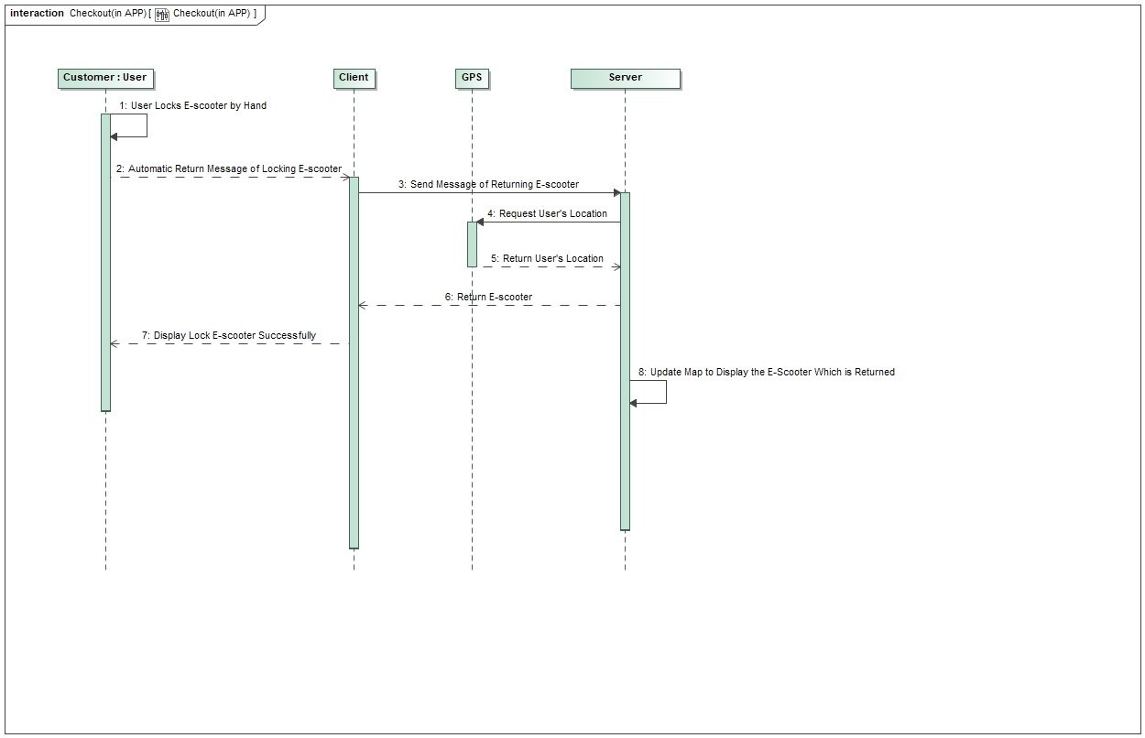

Location check:

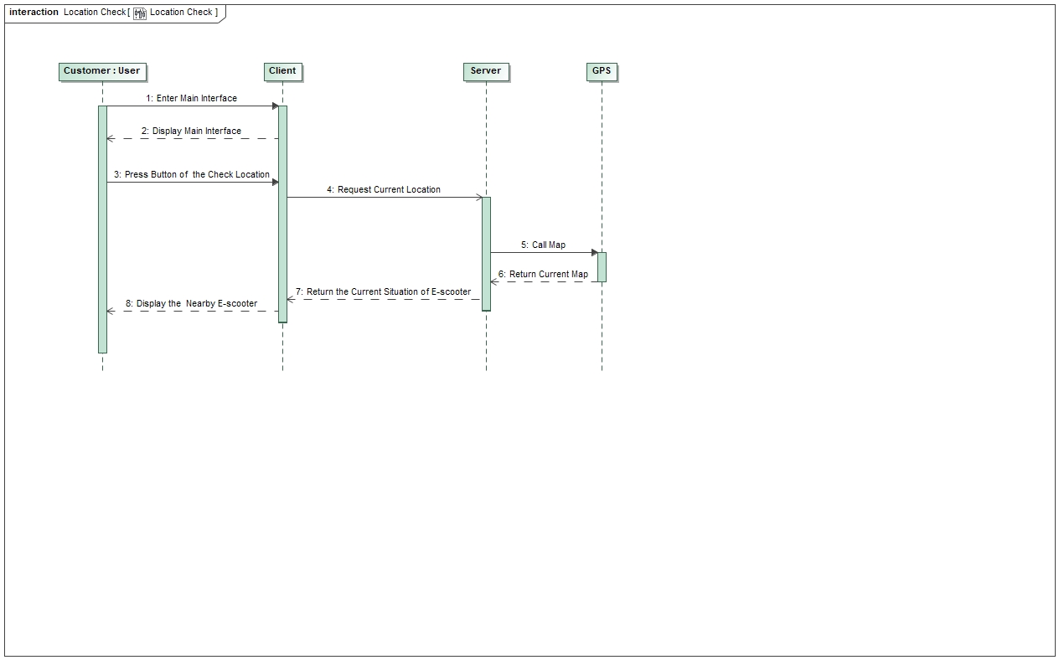

Report error:

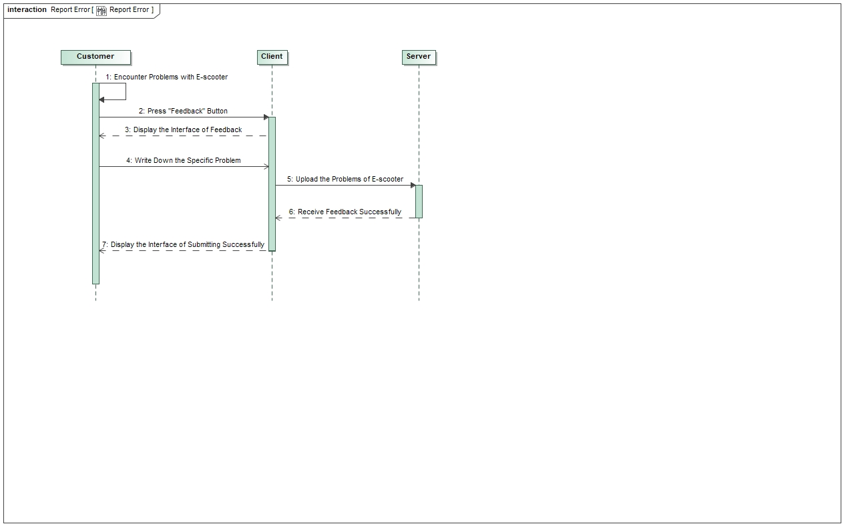

Partner report alert:

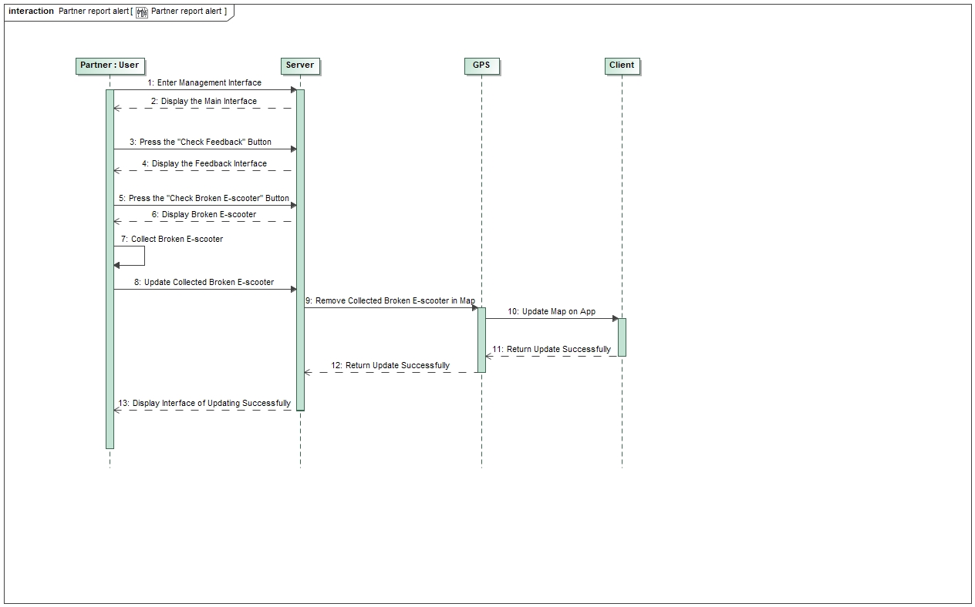

Reservation of e-scooter:

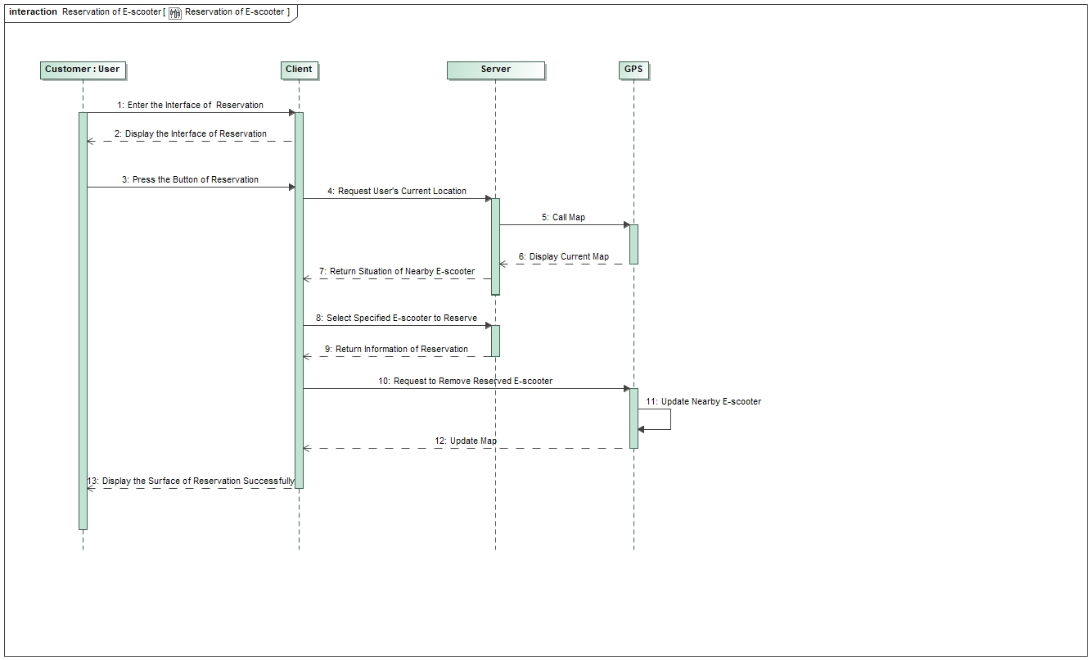

Check Status:

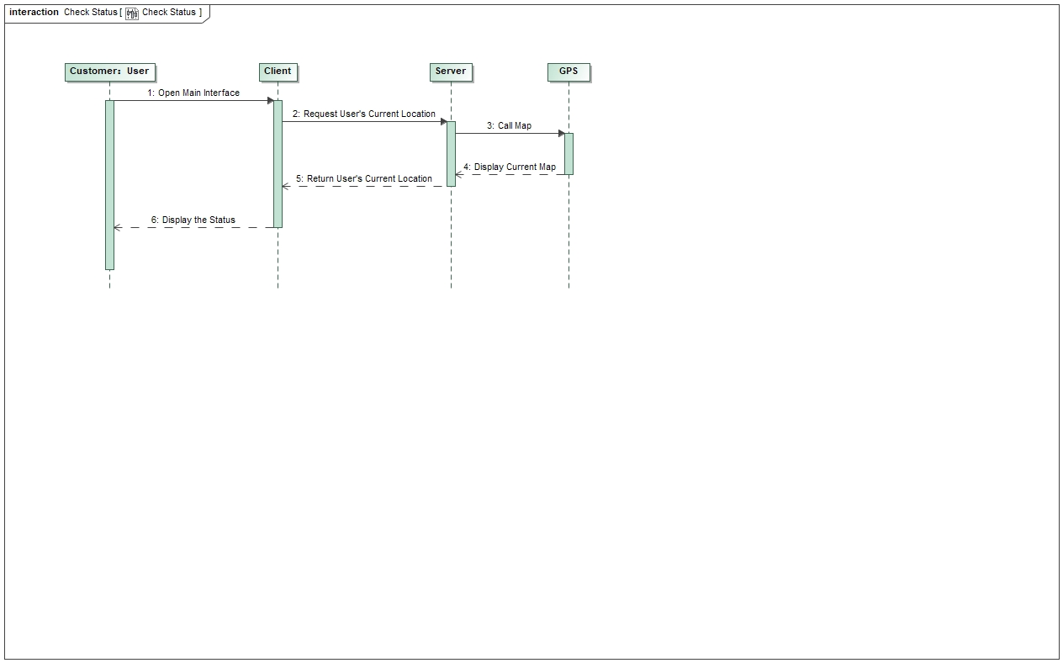

Promo Codes:

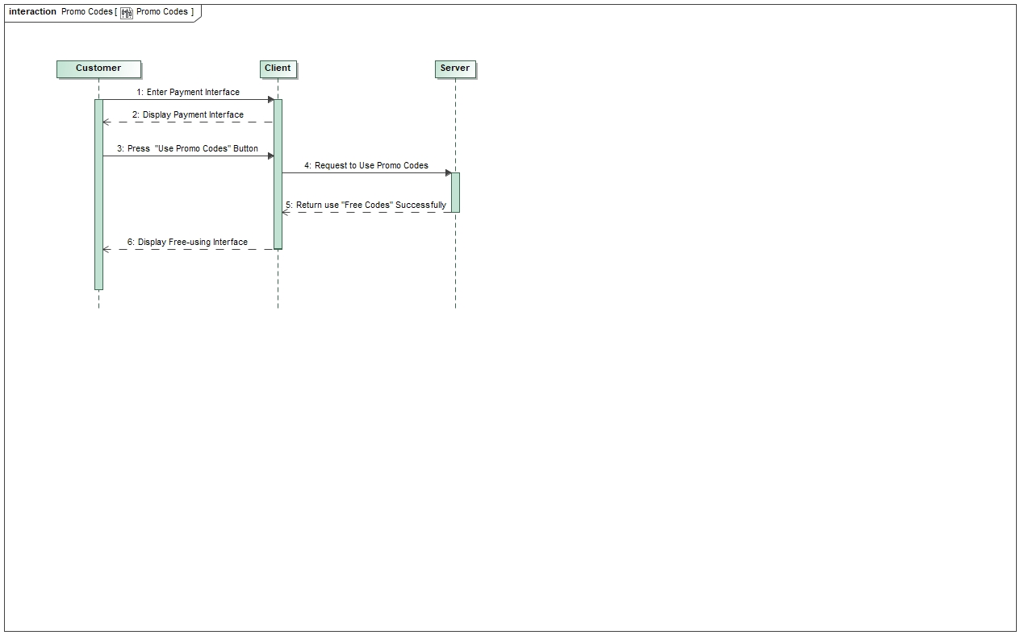

Alternative google login:

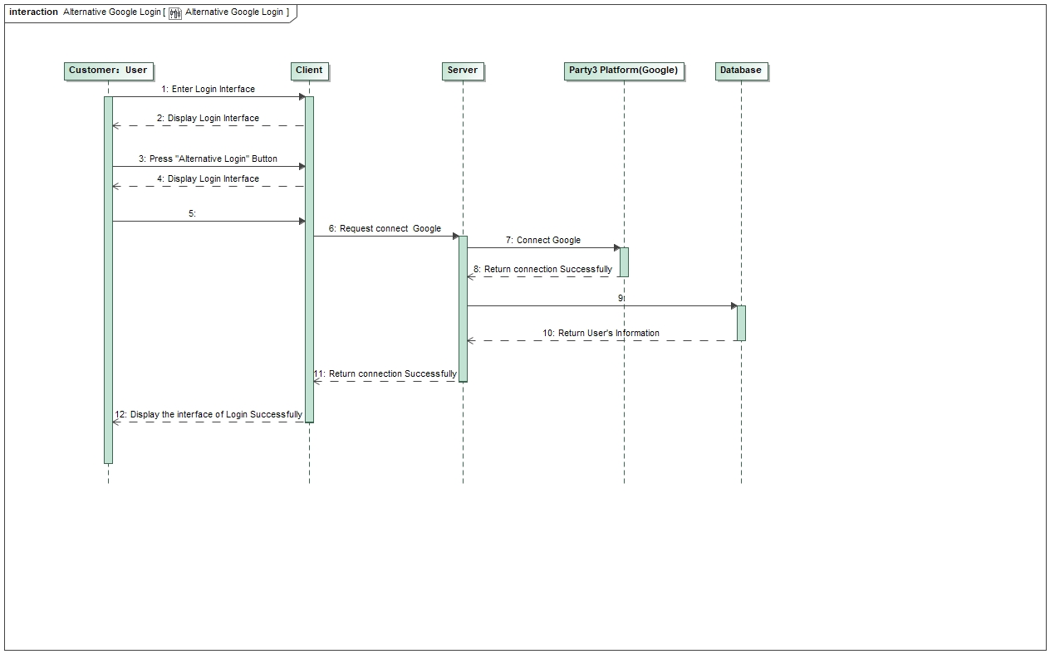

Book VIP package:

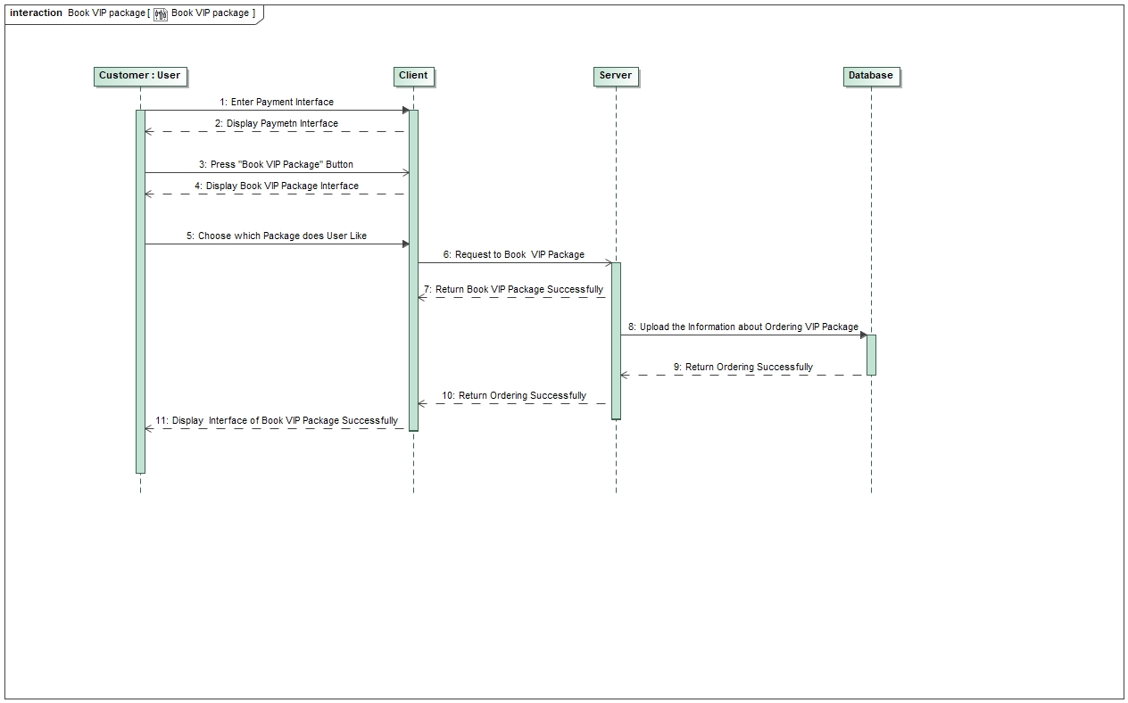

## Activity Diagram:

Customer register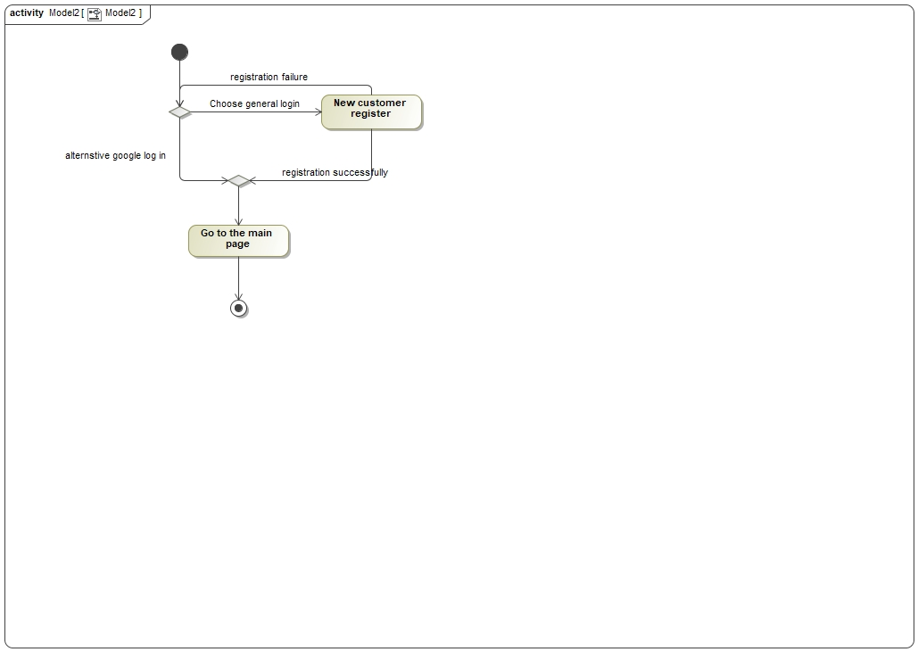

Customer scan E-scooter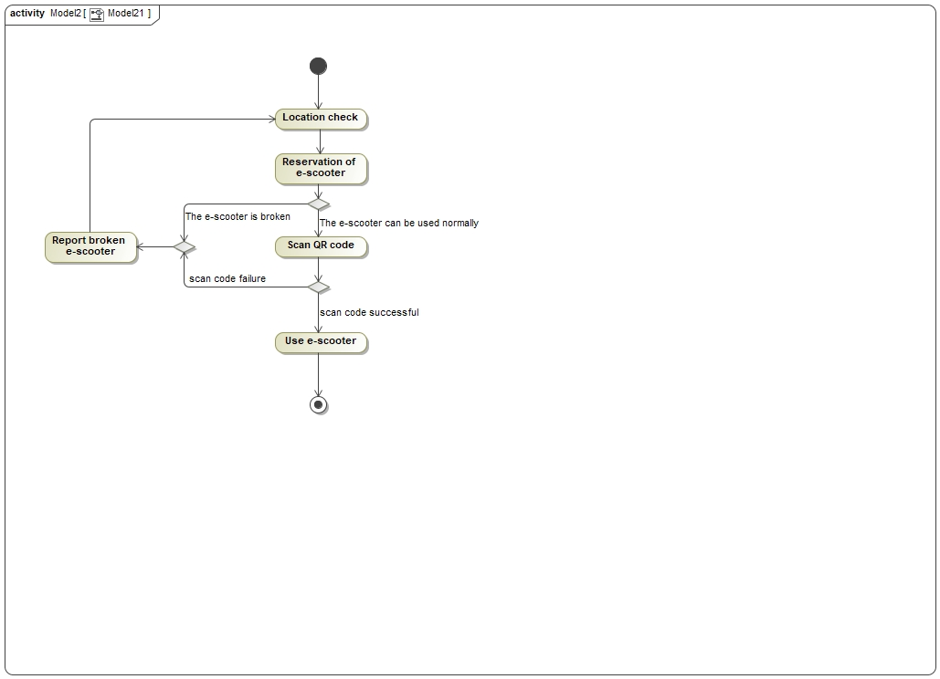

Return E-scooter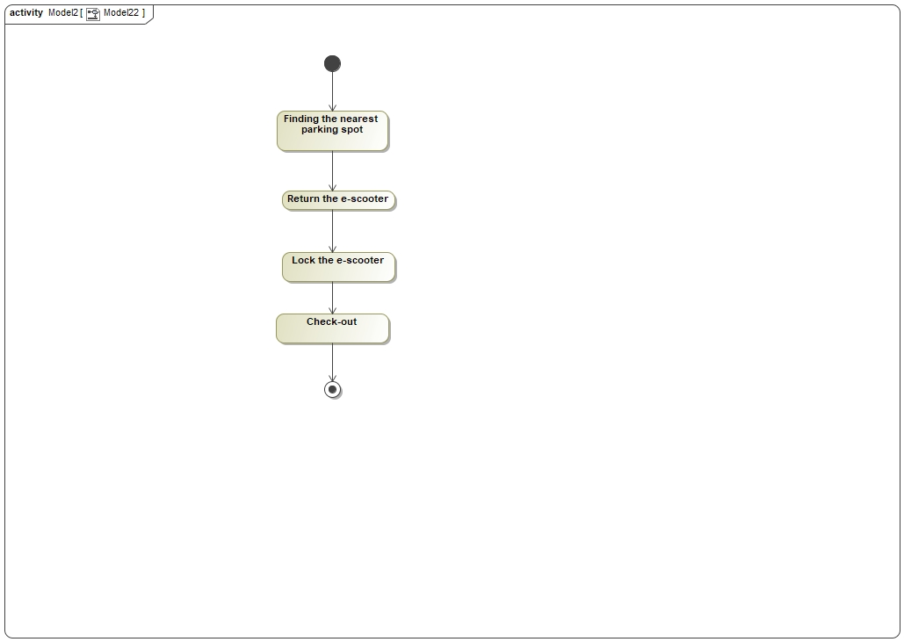

Customer Payment

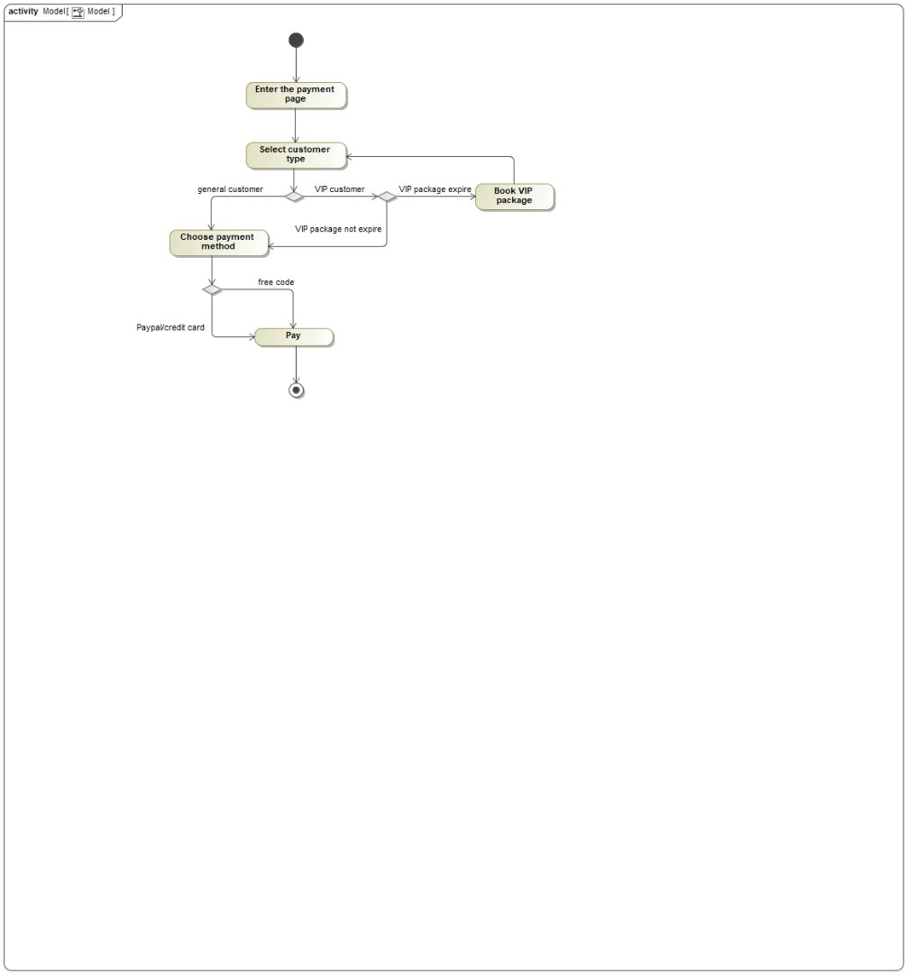

Notes: This activity diagram covers most functionalities and is therefore sufficient.

## Use Case Diagrams:

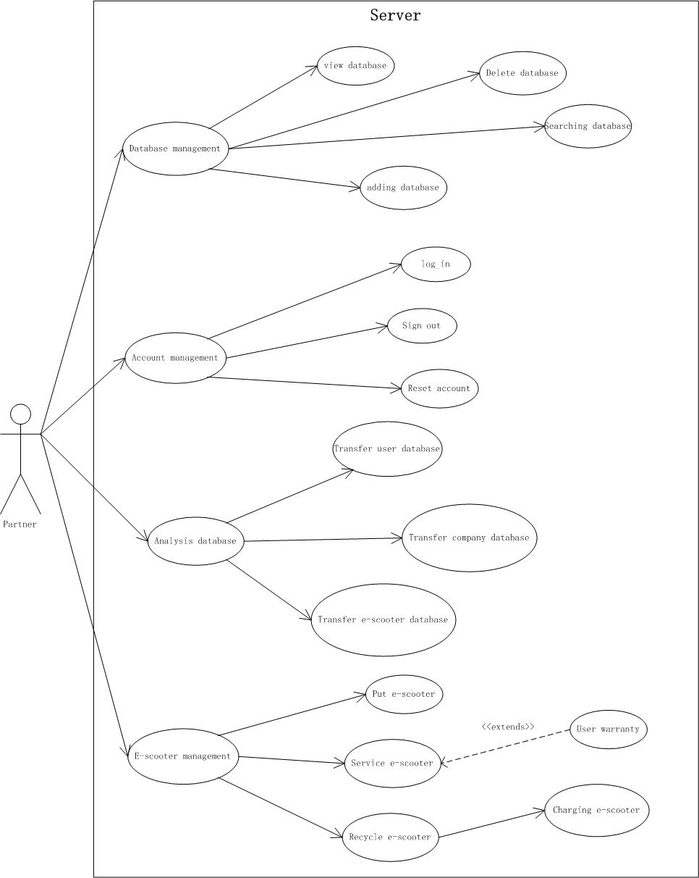

The server-side UML includes every back-end item on the backlog. That means all databases are included (user database, company database). The analyzation of costs and profits is done server-side, by hidden back-end calculations (covered in backlog item: company database). This diagram also shows the communication of the server with the e-scooters (covered in the backlog item: location check, report broken scooters & partner report alert).

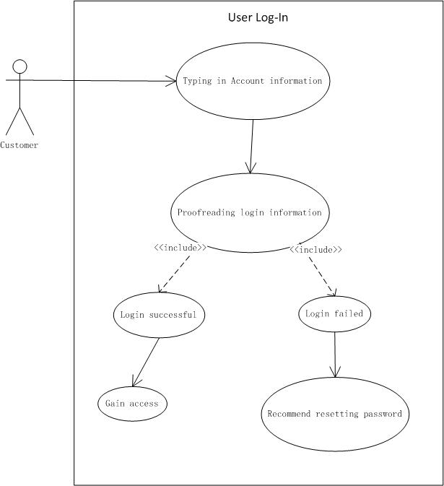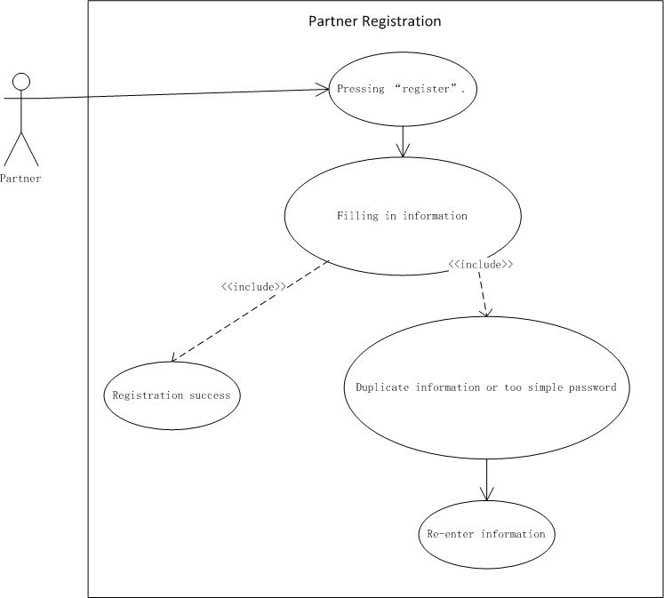 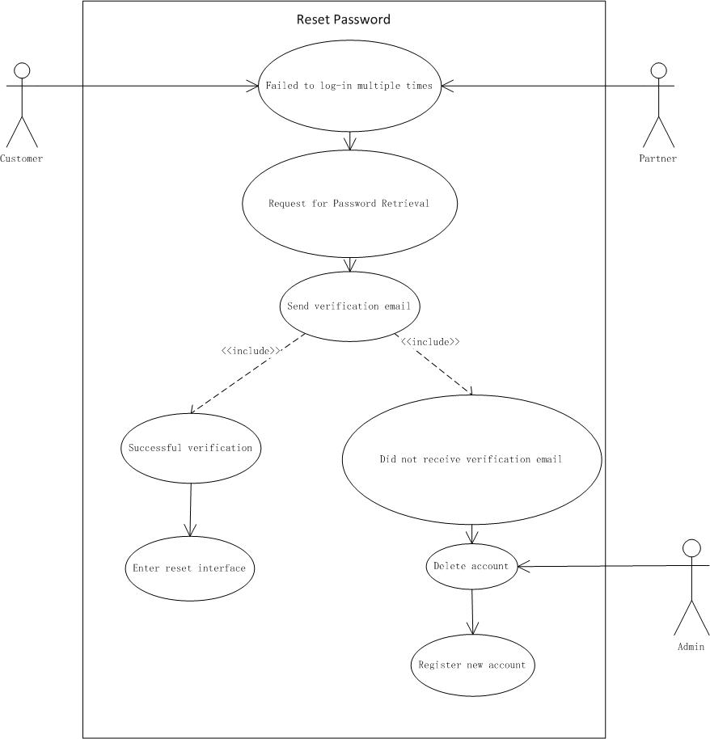

This covers all backlog items like customer registration and partner registration. This does not apply to the alternative google log-in

User registration contains all backlog items that are related to the registration process. It sums up all registration backlog items (customer & partner registration) excluding google log-in.

This includes the backlog items directly related to the registration process (partner registration, customer registration), excluding the google log_in.

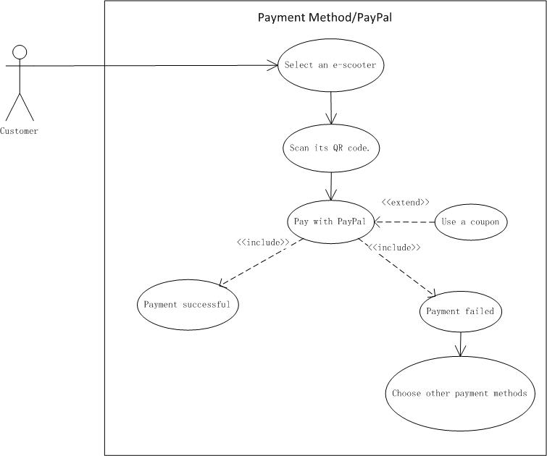

Backlog items: Paypal; Coupon

